#6 Own-Occ for Dentists Template
To use this template, you will need:
- An email sending platform. Constant Contact and Mailchimp are good options. You may be able to start with a free trial.
- An email mailing list saved in Excel. Your list should contain an email address for each prospect. You will need to upload your list to your email sending platform.
- Your logo to insert into the template.
- Your DIS quote engine URL. If you don’t have this, contact it@diservices.com to obtain it.
- The quote engine icon you wish to use. You can download the color and size of your choice at https://www.diservices.com/quote-engine-icons
To set up your email:
- Log in to your email platform and start a new project/email.

- Upload your images, including:
  - The header image of this email.
  - Your company logo
  - Your quote engine icon
To upload images, you will right click on the image in this Word doc, save it to your computer and then upload it to your email platform.
- Copy and paste the text in this Word document into the email platform. Adjust the formatting, spacing and font size – 14 pt. usually works well in HTML emails.

- Add your contact information where it is noted.

- Insert the quote engine hyperlinks into the underlined “request a quote” text as well as into the quote engine icon.

- Insert your email address into the underlined “contact me” text.

- Consider linking the header image to your website, if you have one.

- Add the subject line.

- Send yourself a test email, so you can verify the links are working and everything looks good.

- Upload your list and schedule your email.
Subject Line: Dentists: Don’t Settle for Anything Less Than Own-Occupation Protection

Good News!

The highly desirable Own-Occupation definition is now available for dentists. Originally developed for physicians, the Own-Occupation definition pays benefits based on your ability to perform your current duties as a dentist. Even if you were able to return to work in a less lucrative dental capacity, you would be paid benefits based on your current income level.

When was the last time you reviewed your disability insurance policy? If your income has increased over the years, the policy you purchased a while back may no longer be sufficient. Plus, with the new addition of the Own-Occupation definition, now is a perfect time to update your protection.

Request a complimentary quote today or contact me to learn more.

Warm regards,
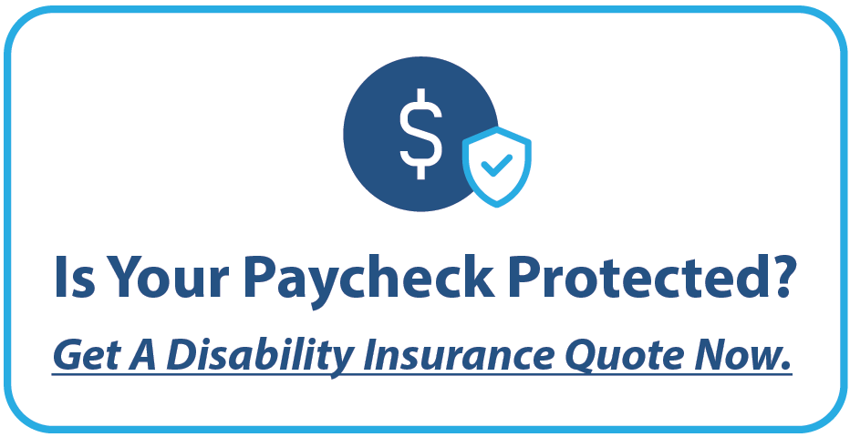

<Insert Broker Name>
<Insert Broker Phone Number>
<Insert Broker Email Address>
<Insert Broker Logo>

