#21 – DI for Veterinarians
To use this template, you will need:
- An email sending platform. Constant Contact and Mailchimp are good options. You may be able to start with a free trial.
- An email mailing list saved in Excel. Your list should contain an email address for each prospect. You will need to upload your list to your email sending platform.
- Your logo to insert into the template.
- Your DIS quote engine URL. If you don’t have this, contact it@diservices.com to obtain it.
- The quote engine icon you wish to use. You can download the color and size of your choice at https://www.diservices.com/quote-engine-icons
To set up your email:
- Log in to your email platform and start a new project/email.

- Upload your images, including:
  - The header image of this email.
  - Your company logo
  - Your quote engine icon
To upload images, you will right click on the image in this Word doc, save it to your computer and then upload it to your email platform.
- Copy and paste the text in this Word document into the email platform. Adjust the formatting, spacing and font size – 14 pt. usually works well in HTML emails.

- Add your contact information where it is noted.

- Insert the quote engine hyperlinks into the underlined “request a quote” text as well as into the quote engine icon.

- Insert your email address into the underlined “contact me” text.

- Consider linking the header image to your website, if you have one.

- Add the subject line.

- Send yourself a test email, so you can verify the links are working and everything looks good.

- Upload your list and schedule your email.
Subject Line: Have You Protected Your Practice from the Threat of Disability?
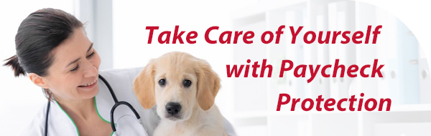
Greetings!

You’ve invested time and money into a rewarding career as a veterinarian. But what if something goes wrong?

An injury or illness can change everything overnight. When people become disabled, it’s not just their health that suffers. Their finances also take a hit. If an injury or illness prevented you from working, how long would your savings last? How would you be able to cover your mortgage, student loan, bills, groceries and other costs after that? And what would happen to your clinic in the meantime?

Fortunately, paycheck protection is available. You can purchase individual disability insurance to protect your own income. If you own your veterinary clinic, you can also purchase a business overhead expense policy to cover overhead expenses if you become disabled. Other policies, including key person disability insurance, business loan disability insurance and multi-life disability insurance are also available to meet the needs of you and your clinic.

Request a complimentary quote today or contact me to learn more.

Warm regards,

<Insert Broker Name>
<Insert Broker Phone Number>
<Insert Broker Email Address>
<Insert Broker Logo>

