#15 Future Purchase Option
To use this template, you will need:
- An email sending platform. Constant Contact and Mailchimp are good options. You may be able to start with a free trial.
- An email mailing list saved in Excel. Your list should contain an email address for each prospect. You will need to upload your list to your email sending platform.
- Your logo to insert into the template.
- Your DIS quote engine URL. If you don’t have this, contact it@diservices.com to obtain it.
- The quote engine icon you wish to use. You can download the color and size of your choice at https://www.diservices.com/quote-engine-icons
To set up your email:
- Log in to your email platform and start a new project/email.

- Upload your images, including:
  - The header image of this email.
  - Your company logo
  - Your quote engine icon
To upload images, you will right click on the image in this Word doc, save it to your computer and then upload it to your email platform.
- Copy and paste the text in this Word document into the email platform. Adjust the formatting, spacing and font size – 14 pt. usually works well in HTML emails.

- Add your contact information where it is noted.

- Insert the quote engine hyperlinks into the underlined “request a quote” text as well as into the quote engine icon.

- Insert your email address into the underlined “contact me” text.

- Consider linking the header image to your website, if you have one.

- Add the subject line.

- Send yourself a test email, so you can verify the links are working and everything looks good.

- Upload your list and schedule your email.
Subject Line: Don’t Miss This Crucial Window of Opportunity!

Greetings!

Did you know that similar to bad teeth, your disability insurance policy has a crucial window of opportunity?

It’s true! You have a special policy feature called the Future Purchase Option that allows you to increase your coverage once a year – on your anniversary date, without health underwriting. If your income has gone up since you purchased your policy, your policy benefits should be increased too.

Here are three great reasons to review your coverage levels now:

- Your income may have increased since you purchased your policy
- You can secure more coverage using rates based on your age at the time of the original purchase
- During the Future Purchase Option window of opportunity, no medical exam is required

You already made a wise choice to protect your earning power. Now, take your benefits to the next level by exercising your Future Purchase Option.

Request a complimentary quote today or contact me to learn more.

Warm regards,
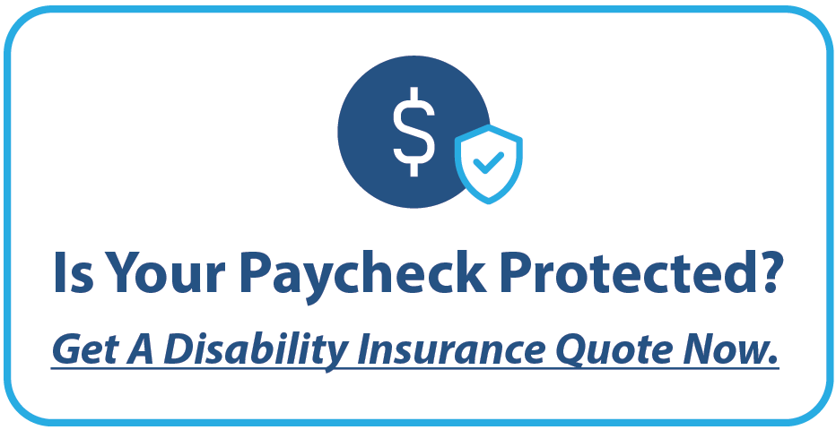

<Insert Broker Name>
<Insert Broker Phone Number>
<Insert Broker Email Address>
<Insert Broker Logo>

