#13B Doctors Closer Look
To use this template, you will need:
- An email sending platform. Constant Contact and Mailchimp are good options. You may be able to start with a free trial.
- An email mailing list saved in Excel. Your list should contain an email address for each prospect. You will need to upload your list to your email sending platform.
- Your logo to insert into the template.
- Your DIS quote engine URL. If you don’t have this, contact it@diservices.com to obtain it.
- The quote engine icon you wish to use. You can download the color and size of your choice at https://www.diservices.com/quote-engine-icons
To set up your email:
- Log in to your email platform and start a new project/email.

- Upload your images, including:
  - The header image of this email.
  - Your company logo
  - Your quote engine icon
To upload images, you will right click on the image in this Word doc, save it to your computer and then upload it to your email platform.
- Copy and paste the text in this Word document into the email platform. Adjust the formatting, spacing and font size – 14 pt. usually works well in HTML emails.

- Add your contact information where it is noted.

- Insert the quote engine hyperlinks into the underlined “request a quote” text as well as into the quote engine icon.

- Insert your email address into the underlined “contact me” text.

- Consider linking the header image to your website, if you have one.

- Add the subject line.

- Send yourself a test email, so you can verify the links are working and everything looks good.

- Upload your list and schedule your email.
Subject Line: Sometimes It Pays to Take a Closer Look

Greetings!

You examine your patients’ x-rays every day, often discovering risks not apparent to the human eye. But how often do you examine your own risks?

You’ve invested a great deal of time and money to build your practice and your earning power. But what happens to those assets if you are unable to work due to illness or injury? Can you maintain your lifestyle and achieve your dreams?

You could … if you had the right disability insurance plan.

Depending on your needs you can choose a plan or combination of plans that:
- Protect your income if you are unable to return to your full duties
- Continue retirement contributions on your behalf
- Cover business expenses
- Protect any business partners
- Protect your revenue if a key employee is disabled

Request a complimentary quote today or contact me to learn more.

Warm regards,
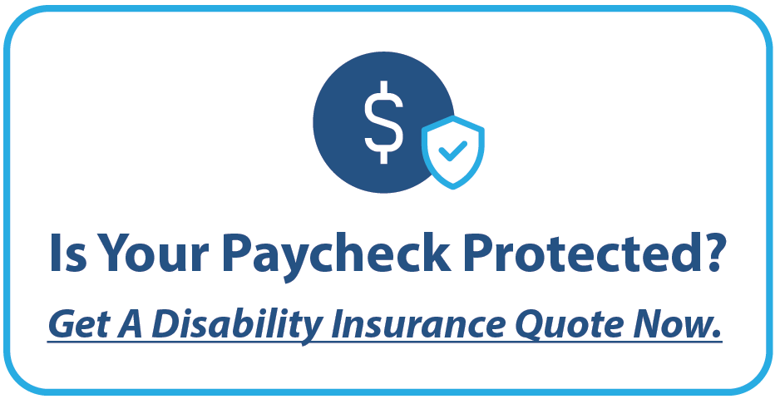

<Insert Broker Name>
<Insert Broker Phone Number>
<Insert Broker Email Address>
<Insert Broker Logo>

